Software Requirements Specification

Author：liudaxia&linbiyuan

Directory

1. Introduction---------------------------------------------2

1.1 Purpose --------------------------------------------2

1.2 Scope ----------------------------------------------2

1.3 Define ----------------------------------------------2

1.4 Reference------------------------------------------- 3

2. Overall Description

2.1 Product perspective-----------------------------------3

2.2 Product features------------------------------------- 4

2.3 User Characteristics ---------------------------------- 5

3.Specific Requirements

3.1 Page -----------------------------------------------5

3.2 External interface requirements-------------------------8

3.3 Performance requirements-----------------------------8

3.4 Security---------------------------------------------8

3.5 Maintainability -------------------------------------- 9

3.6 Requirements for personnel --------------------------- 9

3.7 Operation requirements------------------------------ 10

**1. Introduction**

1.1 Purpose

1. Identifying differentially expressed genes given a gene expression file containingtwo cell samples.

2. When scientists do experiments, they often repeat a large number of data comparisons. In order to get the comparison result more quickly, conveniently and accurately, we can make a template and by entering data, the computer performs the operation in a fixed way and return the result.

1.2 Scope

Identifying differentially expressed genes given a gene expression file containingtwo cell samples.

1.3 Definitions, Acronyms and Abbreviations

1. Control sample - a cell sample prepared in its normal condition.

2. Treatment sample - a cell sample treated by special chemicals, or in which some genes are altered.

3. Differentially expressed genes - the genes which have significantly different expression levels between two samples.

4. Up-regulation - a gene is said to be up-regulated if it has higher expression intreatment than in control.

5. logFC - log fold change of gene expression. log_2 [T/C], where T is the gene expression level from a treatment sample, while C is the gene expression level from acontrol sample.

T:treatment .

C:control

1.4 Reference

nothing

**2.Overall Description**

2.1Product perspective

1. Provides a fixed format for uploading text.

2. Input

A valid submitted gene expression file has the following format. It is a TAB-delimited, plain text file with three columns (see the attached file for a full example). The file contains an optional head line, followed by each gene's expression in a control sample (e.g., ControlSample) and in a treatment sample (e.g.KnockOutSample).

gene_id ControlSample KnockOutSample

AT1G01010 1.198558083 2.036161827

AT1G01020 13.75736234 13.370796

AT1G01030 0.833779536 0.203616183

AT1G01040 9.58846466 7.126566394

AT1G01046 0 0

AT1G01050 23.81482799 21.10821094

AT1G01060 0.625334652 1.221697096

AT1G01070 1.719670292 0.950208853

AT1G01080 28.34850421 25.24840665

AT1G01090 58.26034505 42.96301455

AT1G01100 1066.508249 1308.030358

AT1G01110 2.709783491 1.425313279

3.Output

The web application displays a table and a scatter plot given a gene expression file.

The table contains a list of differentially expressed genes with the following

format:

gene_id control_sample treat_sample log_2[FC]

AT1G01010 1.198558083 2.036161827 0.76

The scatter plot displays differentially expressed genes. The X-axis is Control, and

Y-axis is Treatment.

Replace 'Control' and 'Treatment' with appropriated column names if provided in the

uploaded file. The up-regulated genes are shown in red dots, and down-regulated

genes are shown in blue.

2.2 Product features

1. Easy to operate：Users can get results just by uploading their data to the system.

2. Accuracy：Computers are far less likely than humans to make mistakes.

3. To save time：Upload all data at once through a computer to computer，it saves a lot of repetitive work. It also saves a lot of time by using the computer's fast computation.

4. Correctness : Ensure the correctness of data processing. First, the software needs to discriminate the input gene files, the data can be processed and analyzed only for the effective gene files. The system has fault tolerance, and has certain ability for erroneous bus instructions and data. For abnormality, it can be found and reported in time

5. When the operation is complete, there is a unified standard prompt message.For example, when deleting an operation, the system can display warning boxes. "Do you confirm deletion records? Unrecoverable after deletion" .After the user clicks on the confirmation, the system will perform the delete operation. After deleting, the user can directly return to the relevant page.

2.3 User Characteristics

scientists:Scientists to upload gene expression files and quickly get differentially expressed genes.

**3. Specific Requirements**

* 1. Page
     1. Information Display on Start Page

1. Prompt text：Prompt user to download the upload file format.
2. The web application has a simple interface with a single button [Upload and GO].

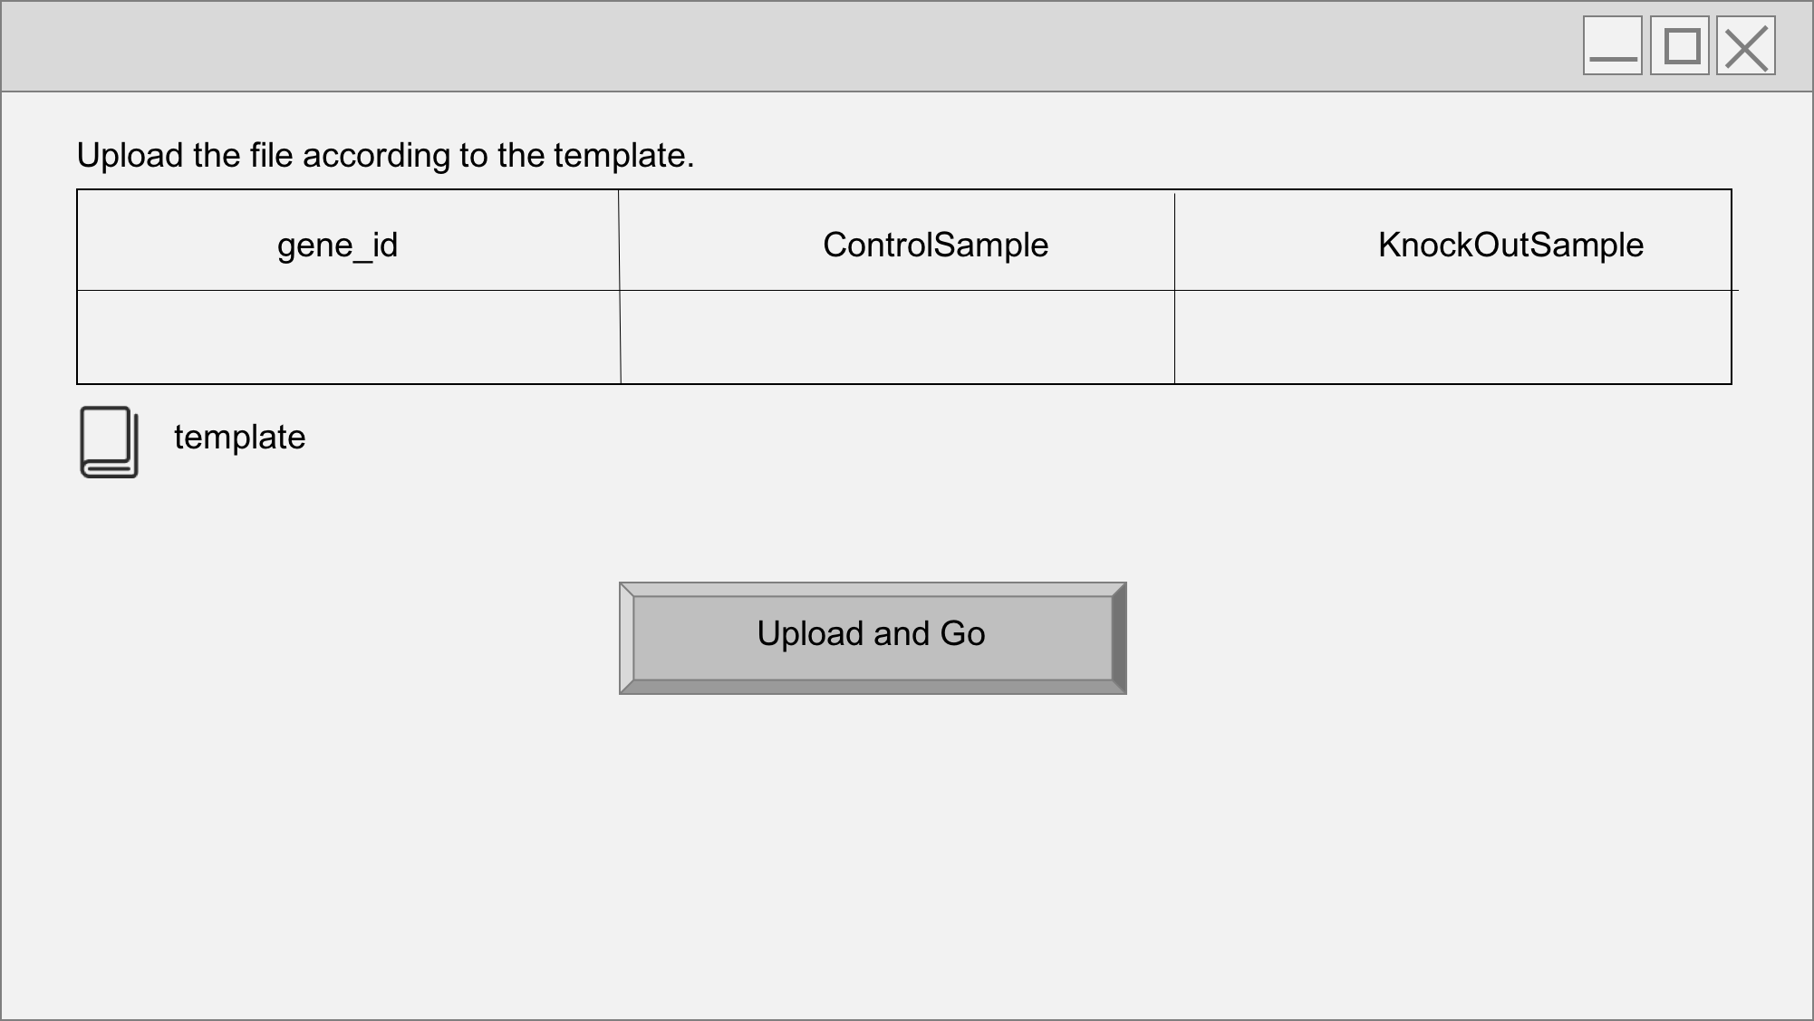

* + 1. Information Display on Upload and GO button

1. Click on Upload and GO button ,the user selects the file and uploads it.
   * 1. Information Display on Result Page

1.Accepting the file, the softwarewill return a table of differentially expressed genes and a scatter plot of thesegenes whose X-axis is control and Y-axis is treatment.

（1）Provide the interface to download the returned result file（Automatically named Result1、Result2、Result3、Result4 and so on）, and the user can preview online or download the file to local.

（2） the user can rename the returned result and add it to the favorites.

1. Users can share with their friends via QQ, WeChat and weibo.
2. If an invalid gene expressionis given, the web application returns a page informing the user to provide the correct format.

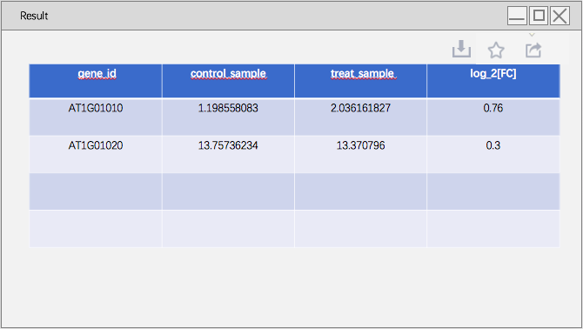

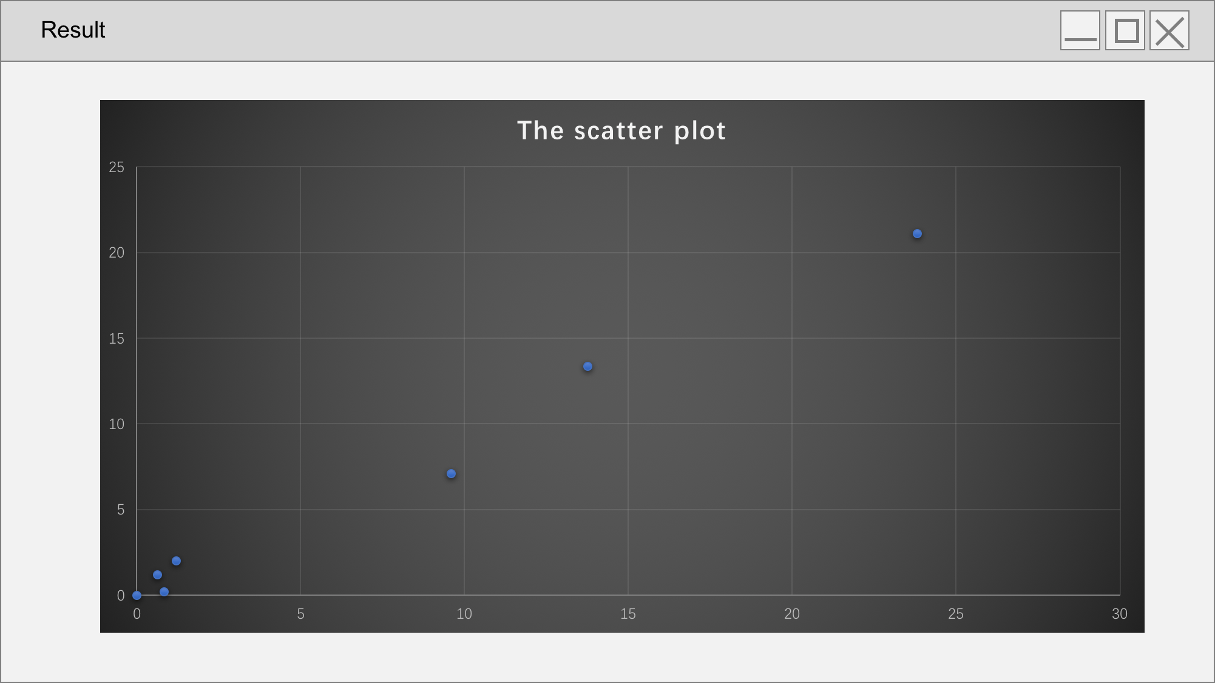

* + 1. Information Display on Record Page

The record page can hold the last ten records. Each record is marked with time that the result be produced. Click the record to view the results online.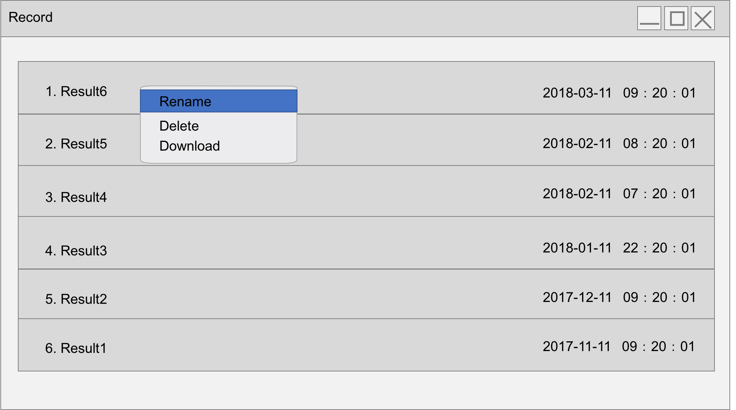

* + 1. Information Display on Favorites Page

1. Can accommodate up to 200 collections.
2. There is a trash sign in the bottom right corner of the page, and the collection can be deleted by clicking on the way of check.
3. Right click the mouse within each collection record can rename、delete and download.

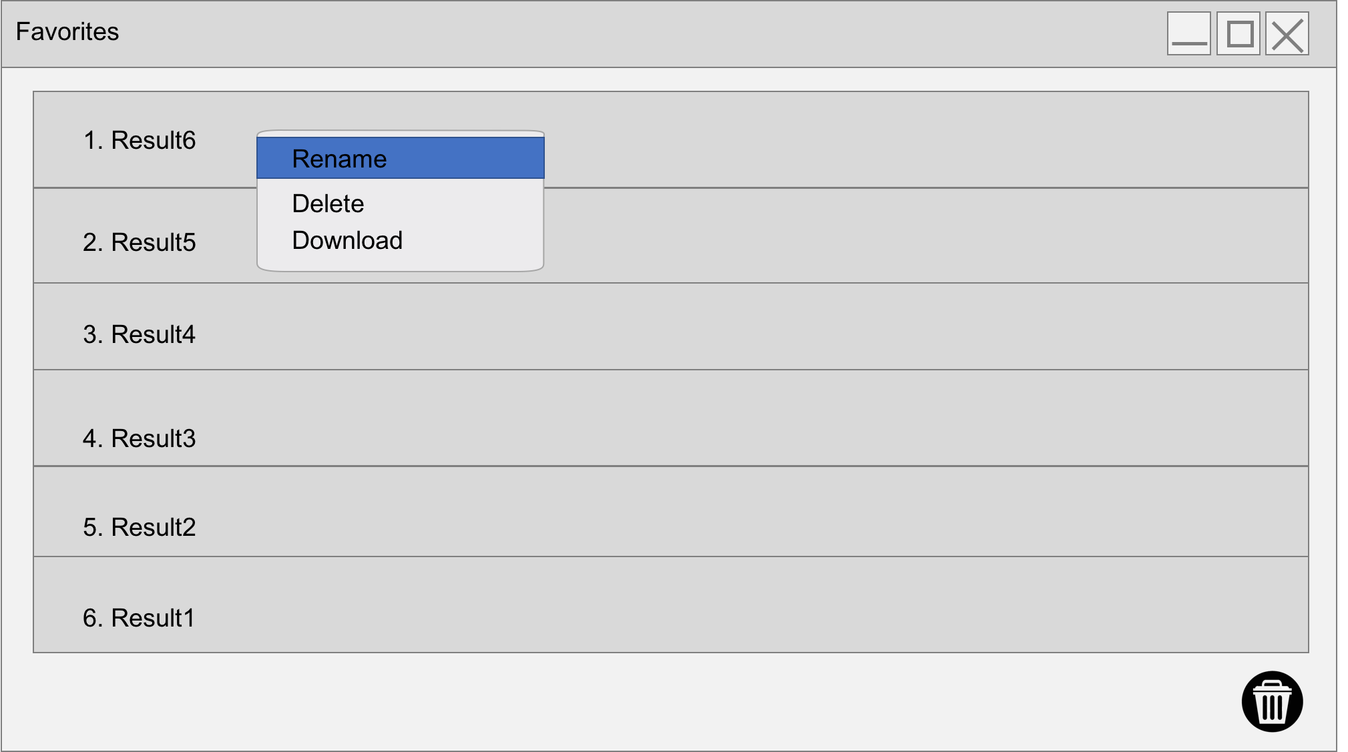

3.2 External interface requirements

3.2.1 User interface.

No special needs.

3.2.2 Hardware interface

No special needs.

* + 1. Software interface.

No special needs.

3.2.4 Communication interface.

No special needs.

* 1. Performance requirements

The response time of the feedback analysis table and scatter diagram is less than 5 seconds.

* 1. Security

1. Data backup

Backup users' uploaded files and analysis result data to deal with data destruction and loss

1. Record user’s log

This software should be able to record all errors occurring during system operation, including native errors and network errors. These errors facilitate developers to find out the causes of errors and improve alignment. Logs also record key operational information of users.

1. Data encryption

Encrypt important information according to a certain algorithm, such as household registration order, important parameters, etc.Eradicate leaking the user's data.

3.5 Maintainability

In the process of use, user feedback can be used to maintain and improve functions.

3.6 Requirements for personnel

1. Project Manager

The project manager can understand the expected product function according to the document, and carry out system design and project management accordingly.

2. Designer

Analyze the demand and design the system, including the design of the database.

3. Programmers

Understand the function of the software and write the user's Manual

4. Testers

Write test cases based on this document, and perform functional testing and non functional testing of software products.

5. Users

When reading this document, you can understand the general picture of the software product, and then understand each function according to your own needs.

3.7 Operation requirements l

1. user interface

（1）The software interface style is unified, the main tone is not more than three or four kinds, with light color as the background, the main text is black, the form lines are fine lines, the interface characters are arranged in order, the related items are clear, and the exaggerated pictures should not be used in general. hardware interface

（2）In the time consuming activities such as data import, export, and so on, a progress display is needed, and the content of the display includes the completed and ongoing work content, progress, time consuming, state, and so on.

1. Hardware Interface

This software does not require specific hardware or hardware interface to support. More than 486 PC can run this software.

1. software interface

Run on Windows95 and later versions of WIN32 + API operating system.

1. Troubleshooting

No mistakes should be made during normal use. If the system is unrecoverable at runtime, the database must be kept intact.

3.8 Data processing requirements

1. Processing accuracy: the accuracy and format of the integrated portal data are consistent with the data accuracy and format of the self-developed software.

2. Processing speed: data processing must meet the requirement of real time. It is limited by the processing speed of the software itself.

3. Maximum information: to meet the upload and download of general project files; data flow rate, allow the longest interruption time and processing time to meet the requirements of file transmission

4. Redundant information processing criteria: data redundancy information from trial project design and operation is not preserved.